

**PROJECT MANAGEMENT PLAN TEMPLATE**

(Group No:22)

**PROJECT MANAGEMENT PLAN**

< Transport Management System Using QR Payment >

|  |  |
| --- | --- |
| **NAME** | **ID** |
| Niloy Gharami | 20-44266-3 |
| Rappy , Md.Abid Hasan | 19-41171-2 |

**Submit DATE 08-12-2024**

1. **PROJECT TITLE:**

**“Transport Management System Using QR Payment”**

# 2.0 OBJECTIVES AND PROJECT SCOPES:

**Objectives:**

* Create a user-friendly smartphone application for managing and booking transportation.
* Add QR code payment capabilities to facilitate simple cashless transactions.
* Use encryption and authentication techniques to ensure data security.
* Offer administrators real-time monitoring and reporting.

**Subobjectives:**

* Create and create the user interface for the mobile application
* Use encryption and payment processing for QR codes.
* Establish a safe database to store user data and transaction history.
* Integrate with the APIs of external suppliers of transportation services.
* Create systems for user authentication and permission.
* Establish an administrative dashboard.

# 3.0 PROJECT JUSTIFICATION:

A Transportation Management System (TMS) combined with a QR scanner has various advantages that justify its use. Here are some reasons why you should use a TMS with QR scanner functionality:

**Efficient Tracking and Visibility:** QR scanners allow for the tracking and viewing of cargo and vehicles in real time. This allows logistics managers to track the precise position, movement, and status of each consignment, which improves overall operational efficiency.

**Accurate Data Capture**: QR scanners capture data accurately and reliably, reducing the risk of manual errors associated with manual data entry. This precision ensures that the relevant cargoes are assigned to the appropriate vehicles and delivered to the appropriate locations.

**Faster Processing:** QR codes are swiftly scanned, saving time during the check-in, check-out, loading, and unloading processes. This speed helps to reduce supply chain wait times, congestion, and delays.

**Enhanced Security**: QR codes can be encrypted and validated, increasing cargo security. This prevents unauthorised access and lowers the likelihood of theft or tampering during travel.

**Reduced Paperwork:** The use of QR scanners to digitise procedures reduces the requirement for manual paperwork dramatically. This not only saves time and resources, but it also helps the environment.

**4.0 PROJECT OVERVIEW:**

The Transport Management System using QR Code payment aims to improve transportation efficiency by integrating QR code technology with transport infrastructure. Passengers can scan QR codes on vehicles or stations, eliminating physical tickets and cash transactions. The system includes backend management tools for improved convenience, reduced transaction time, and better data insights**.**

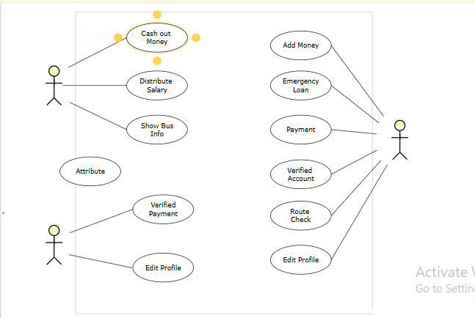

**5.0 MODULES , SCOPES AND FEATURES:**

**5.1 MODULES:**

**5.1/1 User Management Module**

Register and authenticate users (passengers and drivers).Manage user profiles and preferences.

**5.1/2 Transport Booking Module**

Search and book transport options in real-time.Manage trip schedules and availability.

**5.1/3 QR Payment Module**

Generate and scan QR codes for cashless payments.Track payment transactions.

**5.1/4 Administration Module**

Real-time monitoring of fleet and trip data.Generate analytics and reports for system performance.

**5.1/5 Security Module**

Implement encryption for data storage and communication.Authenticate QR codes to ensure secure transactions.

**5.1/6 Notification and Alerts Module**

send trip confirmations, reminders, and updates via SMS or push notifications.Alert administrators about system anomalies or issues.

**5.2 SCOPES:**

Facilitate seamless transportation booking and payment.Replace cash transactions with QR-based payments for efficiency.Provide real-time insights for better operational management.Ensure security and trust in all transactions.

**5.3 FEATURES:**

User-friendly app interface for customers and drivers.

QR-based payment integration supporting multiple payment gateways.Real-time fleet tracking for users and administrators.Reporting dashboards with key metrics like trip statistics and revenue data.Offline QR code payment option for areas with poor connectivity.

**6.0 STAKEHOLDERS ANALYSIS:**

There are two types of stakeholders

* + 1. **Primary Stakeholders:** Primary stakeholders are people or groups who have a clear and important interest in how the project turns out.
       - Passengers
       - Conductor
       - Transportation Authorities
       - Technology Partners
       - Security and Privacy Promoter
    2. **Secondary Stakeholders:** People or groups with a detached or less important interest in the project are secondary stakeholders.
       - Software Developers
       - Hardware providers
       - Insurance Companies
       - Consultants

**7.0 RESOURCE REQUIREMENTS**

**7.1 SOFTWARE REQUIREMENTS:**

* Visual Studio, IntelliJ IDEA, or a comparable Integrated Development Environment (IDE).
* For code management and collaboration, use a version control system (e.g., Git).
* Web development programming languages (for example, Python, Java, JavaScript, and PHP).
* The TMS backend is built using a web framework (e.g., Django, Ruby on Rails, or Laravel).
* Front-end technologies (HTML, CSS, JavaScript) are used to create user interfaces.
* For data storage, use a database management system (such as MySQL or PostgreSQL).
* APIs or libraries for QR code production and scanning.
* APIs for payment gateway integration.
* Server and hosting infrastructure for deployment (e.g., AWS, Azure, Heroku).

**7.2 HARDWARE REQUIREMENTS:**

* Programmers' development computers (desktops/laptops) with sufficient processing power and memory.
* To ensure compatibility, use QA and testing devices such as smartphones, tablets, and laptops.
* TMS and associated databases are hosted on server infrastructure.

**7.3 HUMAN RESOURCE REQUIREMENTS:**

* **Project Manager:**The project manager is in charge of general planning, coordination, and making sure the project is completed on schedule and within budget. In addition to managing the project team, communicating with stakeholders, and reducing risks, the project manager.
* **UI/UX designer:**UI/UX designers are in charge of developing intuitive and aesthetically pleasing user interfaces for mobile applications. They put a lot of emphasis on user interface (UI) and user experience (UX) design.
* **Frontend developers:**These programmers create the user interface and put the UI/UX designers' ideas into practice. They are involved in the mobile application's client-side development.
* **Backend Developers:**Backend developers are in charge of creating the server-side logic, connecting APIs, putting payment processing into place, and maintaining data security.
* **Quality Assurance Testers:**QA testers make sure the application functions as intended and is error-free. They test using a range of gadgets, platforms, and circumstances.
* **Database Administrator:**If your project contains a complicated database structure, a database administrator may be required to effectively design and administer the database.
* **Security Specialist:**A security professional can assist put strong security measures in place to secure user data and payment information given the sensitive nature of payment data.
* **Technical Writers:**Technical writers can produce user manuals, training materials, and guides to aid users in navigating and comprehending the program.
* **Support and Training Personnel:**Personnel for User assistance and Training: Depending on the scope of the deployment, you may require personnel to offer user assistance and training both before and after the launch.
* **Business analysts and stakeholders:**These people will collaborate on the project to gather requirements, verify features, and make sure it satisfies business requirements.

**8.0 TECHICAL REQUIREMENTS:**

**8.1Frontend Development**

* Technology: Flutter or React Native (for cross-platform mobile apps).
* Features: Interactive UI/UX, responsive design, and animations.

**8.2Backend Development**

* Technology: Node.js, Django, or Spring Boot for API development.
* Database: PostgreSQL or MongoDB for user and trip data storage.
* Security: AES encryption for sensitive data and OAuth 2.0 for authentication.

**8.3Payment Integration**

APIs from payment processors like Bkash, Nogod, or Rocket.

**8.4Hosting and Deployment**

Cloud-based hosting using AWS or Google Cloud Platform.

**8.5Monitoring Tools**

Tools like Firebase Crashlytics for error tracking and analytics**.**

**9.0 OPERATING SYSTEM:**

**9.1 For Mobile Application:**

Android 8.0 (Oreo) and above.iOS 13.0 and above.

**9.2 For Administration Dashboard:**

Web application compatible with all modern browsers (Chrome, Firefox, Safari).

# 10.0 PRICING:

|  |  |
| --- | --- |
| **Name** | **Cost** |
| **Management & Implementation** | **1 lakh** |
| **Software Quality Testing** | **1 lakh** |
| **Maintenance** | **50 thousand** |
| **Hardware** | **3.5lakh** |
| **Utility** | **1 lakh** |
| **Total =** | **= 7 lakh** |